**Gamer 2 Boundary Marker Preservation During Boolean Subtraction**

**Objective:** Subtract the cristae object from the inner membrane object in Blender using the Boolean modifier while preserving membrane labels using GAMer 2 boundary markers.

**Necessary Tools**:

* CellBlender with GAMer 2

**Before Beginning:**

* Complete protocol 6 to create the objects you will be using here. Then, smooth only the outer and inner membrane objects using protocol 9. You will smooth the cristae after completing this protocol.
* If your cristae membrane consists of more than one part, make sure to split it into separate objects prior to doing the following steps and repeat for each part accordingly.

**Creating Boundary Markers and Materials:**

1. Create a copy of the object you want to subtract (inner_membrane) from using {Shift+D}, then press {Enter} to avoid displacement.
2. Select the new copy of your object and enter edit mode by pressing {Tab}.
3. Under the GAMer tab, expand the Boundary Marking controls.
4. In the Defined Boundaries box, press the plus button twice to create two new materials.
5. Define the new materials (inner, teal; cristae, green) using the Boundary Marking color swatches.
6. Press {A} while in the 3D viewer to select the entire inner_membrane.001 object, then select the inner material in the Defined Boundaries box and press Assign.

**Boolean Subtraction:**

1. Select the inner membrane. Go to the modifiers tab (a wrench on the toolbar). Select the Boolean modifier option. Change the Operation to “Difference”. Change “BMesh” to “Carve”. Select the object to be subtracted with the drop down menu or use the pipette to grab the raw cristae membrane object. Wait until the subtraction is complete.
2. Press apply to complete the Boolean subtraction.
3. Enter Edit Mode and press {Ctrl+T} to re-triangulate the mesh.

**Reassigning Boundary Markers:**

1. The new invaginations in the inner membrane should be grey, corresponding to an undefined boundary. Click on the inner boundary marker in the Defined Boundaries box, then press select. You should see only the inner membrane portion of the mesh selected.
2. Press {Ctrl+I} to select the inverse of your current selection, this should select all undefined triangles.
3. Select the cristae membrane boundary marker and press Assign.

**Confirming Proper Boundary Assignment:**

1. You can test the boundary assignments by selecting and deselecting materials in the Defined Boundaries box. Each triangle should have only one assigned marker.
2. In order to smooth from here, first re-triangulate.
3. When you smooth the mesh, the colors should be maintained. It is common for a few of the triangles near the junctions to become undefined again. If this happens, simply reassign them after smoothing.

**Gamer 1 Boundary Marker Preservation During Boolean Subtraction**

**Objective:** Subtract the cristae object from the inner membrane object in Blender using the Boolean modifier while preserving membrane labels using GAMer 1 boundary markers.

**Necessary Tools**:

* CellBlender with GAMer 1 <http://www.cnl.salk.edu/~bartol/cellblender_bundle/>

**Before Beginning:**

* Complete protocol 6 to create the inner membrane and cristae objects you will be using here.
* If your cristae membrane consists of more than one part, make sure to split it into parts prior to doing the following steps and repeat for each part accordingly.

**Creating Boundary Markers and Materials:**

1. Create a copy of the object you want to subtract (inner_membrane) from using {Shift+D}, then press {Enter} to avoid displacement.
2. Select the new copy of your object and enter edit mode by pressing {Tab}.
3. Under the GAMer tab, expand the Boundary Marking controls.
4. In the Defined Boundaries box, press the plus button twice to create two new materials.
5. Define the new materials (inner, teal; cristae, green) using the Materials box controls.
6. Press {A} while in the 3D viewer to select the entire inner_membrane.001 object, then select the inner material in the Materials list and press Apply.
7. Exit Edit Mode by pressing {Tab} and select the raw cristae object. Re-enter Edit Mode for this object.
8. Add a material slot by pressing the plus sign once, then select the cristae material to fill this slot.
9. Assign this material to the entire cristae object. (See step 6.)
10. Edit Edit Mode.

**Boolean Subtraction:**

1. Select the inner membrane. Go to the modifiers tab (a wrench on the toolbar). Select the Boolean modifier option. Change the Operation to “Difference”. Change “BMesh” to “Carve”. Select the object to be subtracted with the drop down menu or use the pipette to grab the cristae membrane object. Wait until the subtraction is complete.
2. Press apply to complete the Boolean subtraction.
3. Enter Edit Mode and press {Ctrl+T} to re-triangulate the mesh.

**Reassigning Boundary Markers:**

1. Reassign the boundary markers by selecting the inner membrane material from the materials menu and pressing Select, then select the corresponding boundary marker and press Assign.
2. Press {Ctrl+I} to select the inverse of your current selection, this should select all undefined triangles.
3. Select the cristae membrane boundary marker and press Assign.
4. With the inner membrane object selected in edit mode, create a material slot and a blue “inner_membrane” material (color can be changed with the diffuse menu below)

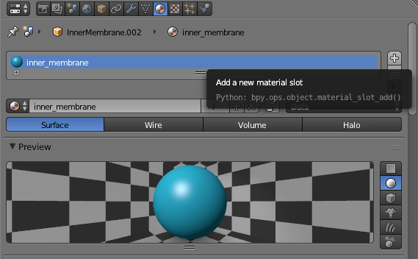

1. With the cristae membrane object selected in edit mode, create a material slot and a green “cristae_membrane” material (color can be changed with the diffuse menu below)

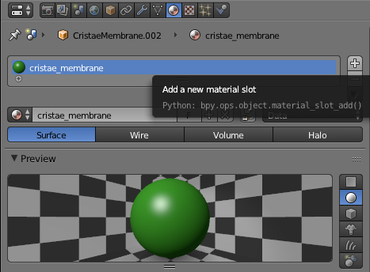

1. Select the inner membrane in edit mode and go into GAMer. Go to boundary marking and add a new boundary marker. Assign the marker to the inner membrane. Repeat with the Cristae membrane.

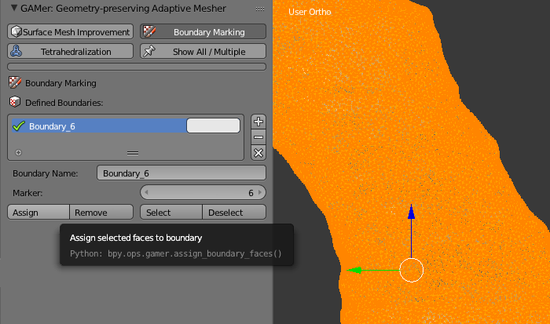

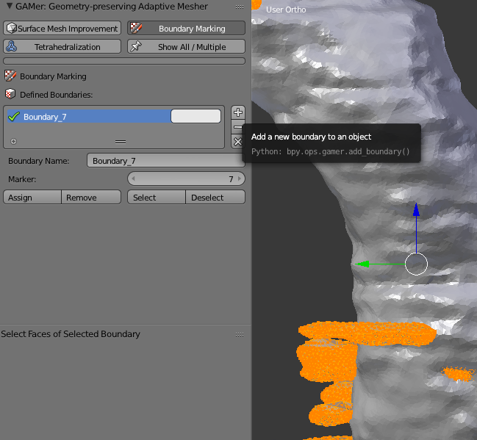

1. Select the inner membrane object in edit mode. Using the special menus tab (an upside down triangle on the scrollbar at the right) in the materials, copy the inner membrane material and paste it onto the inner membrane boundary marker material as shown below. Repeat with the cristae membrane material. Your inner membrane and cristae membrane should now be colored again.

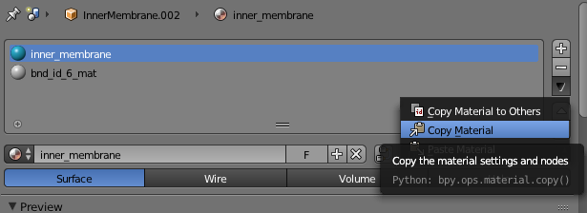

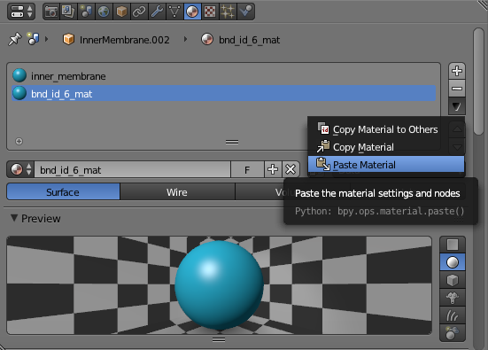

1. Select the inner membrane and go to the modifiers tab (a wrench on the toolbar). Select the Boolean modifier option. Change the Operation to “Difference”. Change “BMesh” to “Carve”. Select the object to be subtracted with the drop down menu or use the pipette to grab the cristae membrane object. Wait until the subtraction is complete.

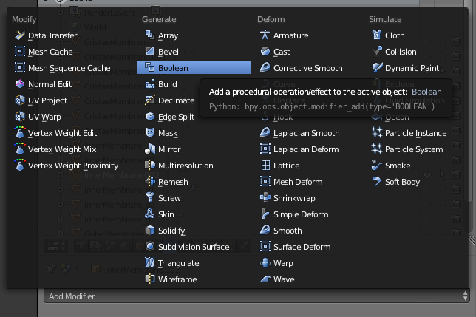

1. Your figure should now appear to have green holes. In order to smooth from here, first re-triangulate. Your cristae-inner membrane boundary may be a little messed up now, so in order to fix that, select the inner membrane object and go to the surface mesh improvement in GAMer and click smooth.
2. Upon smoothing, go to the materials tab with the inner membrane in edit mode and select all items with the “inner_membrane” material. Then go to the boundary marker tab in GAMer and re-assign the boundary marker to these selected triangles. Repeat for the cristae membrane.